*Users Guide to Assetsaaa.com*

First time user login

Find email was sent to you from [support@assetsaaa.com](mailto:support@assetsaaa.com). It contains a temporary password and a link to assetsaaa.com customer login page

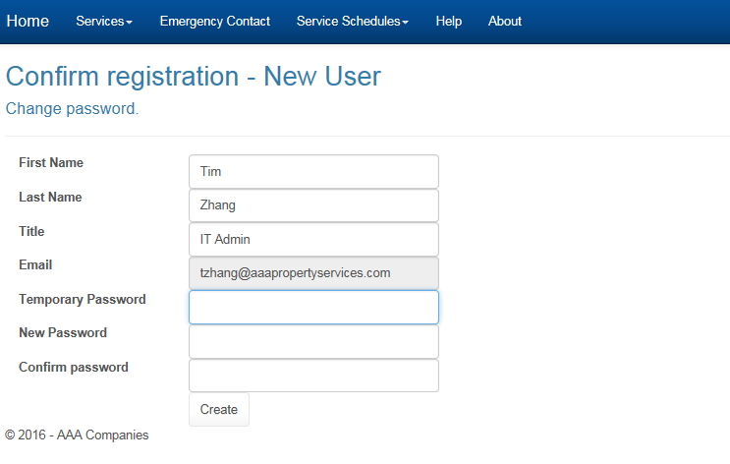

Type temporary password you received from email and input a new password as your choice. Click Create when you are done.

*Existing Portal user log in*

Open up a web browser and go to [www.assetsaaa.com](http://www.assetsaaa.com). Click on **Log in** located in the top right corner

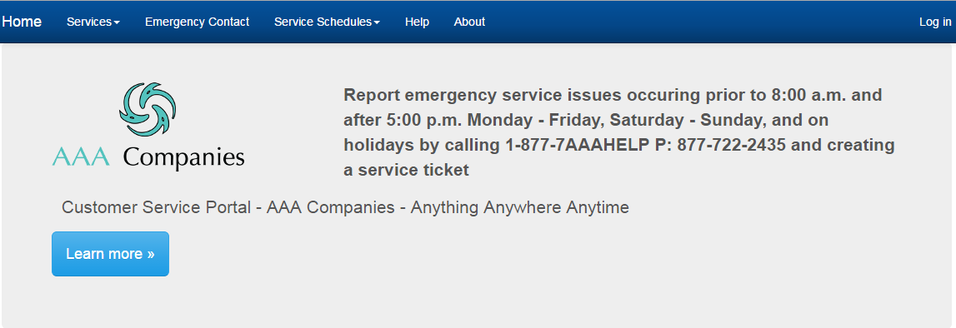

Select “**Forgot your password**” if you are going to rest your password

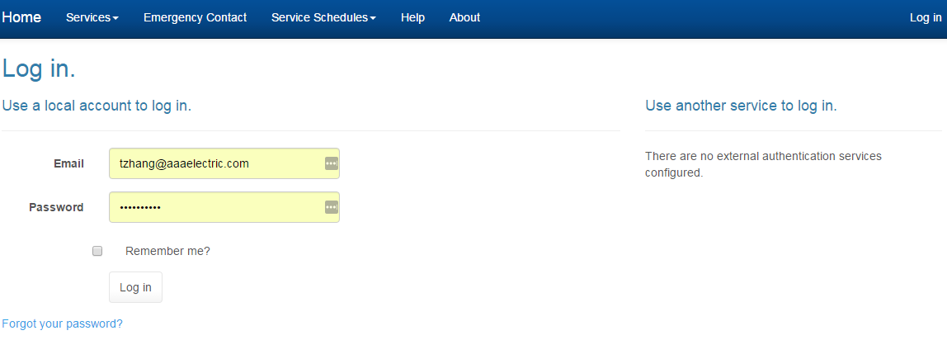

Click on **Log in** located in the top right corner

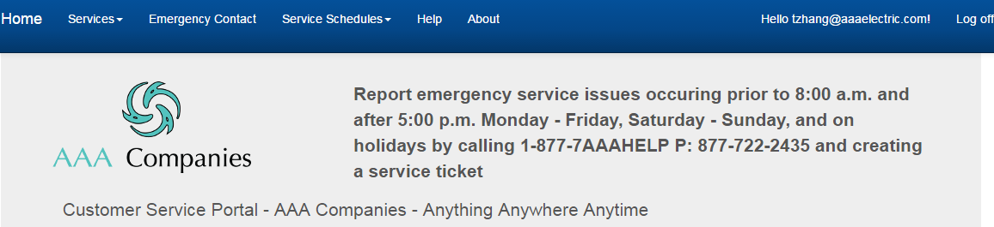

*How to create a service ticket*

Under “**Services**”, select “**Create Service Request**” 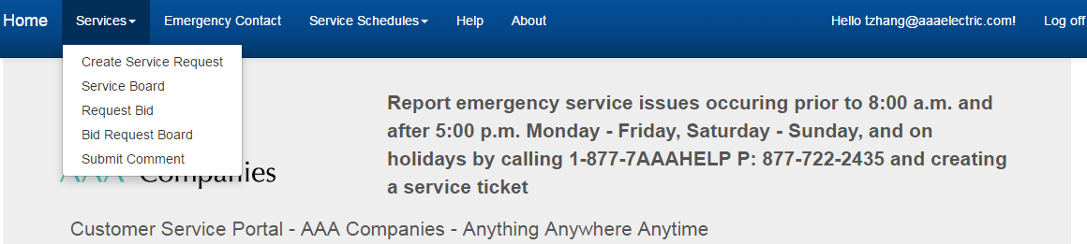

Complete the request form then select “**Create**”. For priority level, please note “Emergency” or “Next Day” priority levels are a premium fee. When possible, select “Next Route Maintenance” as the priority.

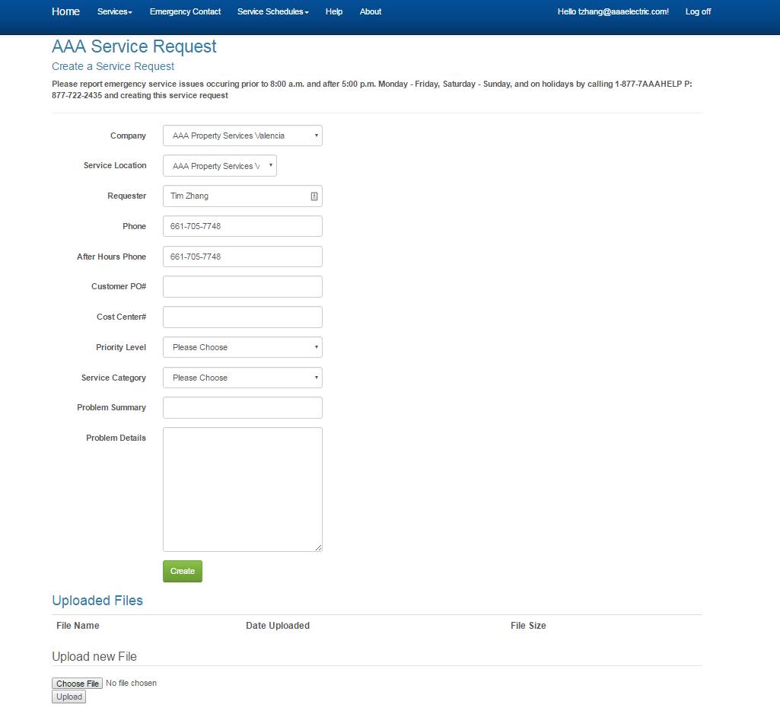

*How to create a Bid Request*

Under “**Services**”, select “**Request Bid**” 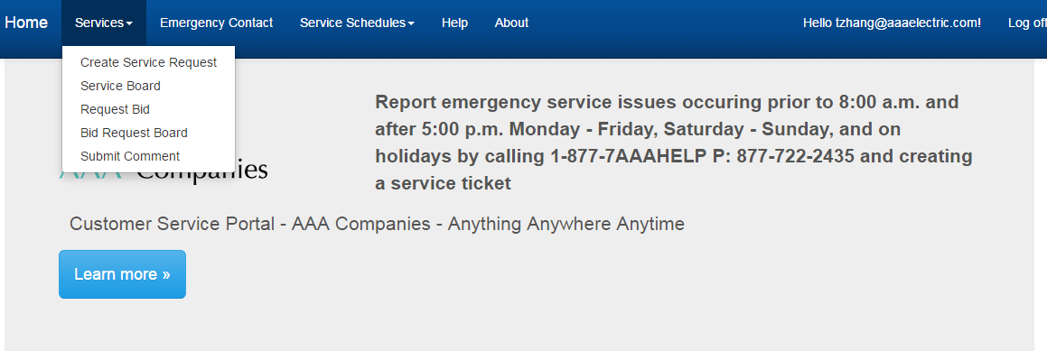

Complete the form then select “**Create**”

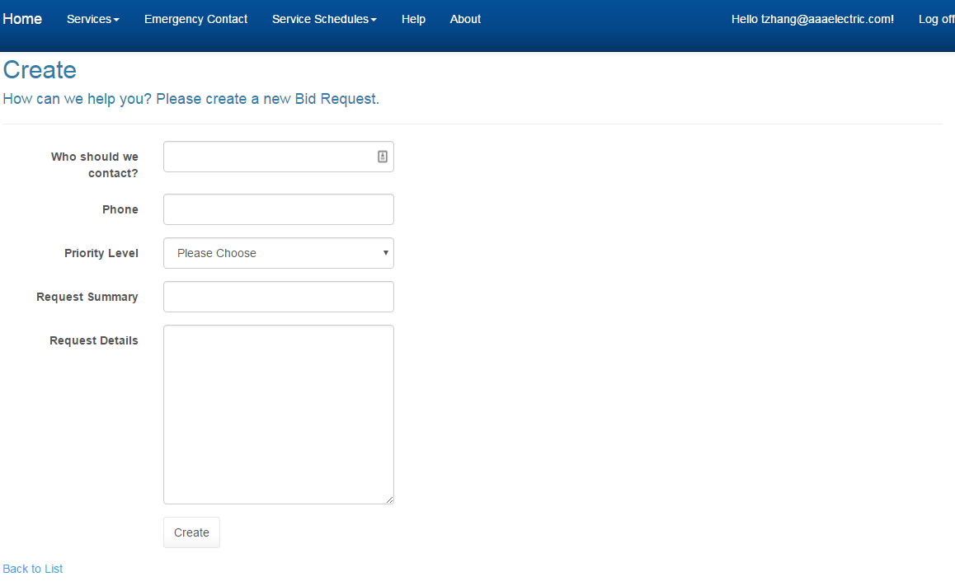

*How to track ticket status and leave extra details*

Under “**Services**”, select “**Service Board**”

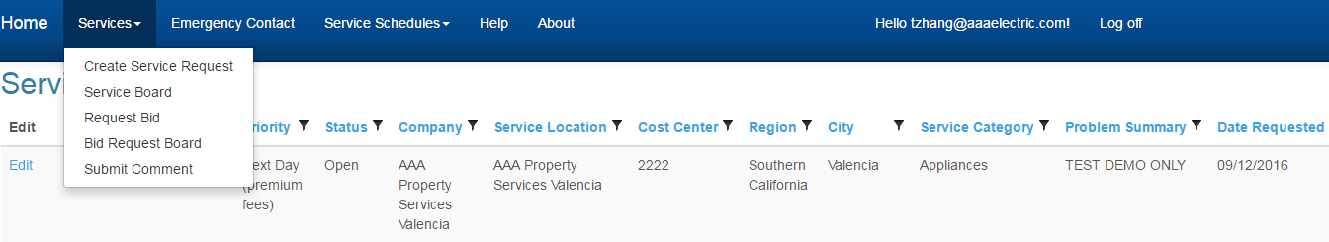

Should you want to make any changes after the initial request is submitted, select “**Edit**” located on the left

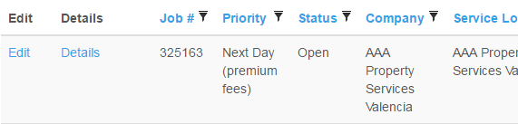

Then select “**Add Details**”, then “**Save**”

